**ONTOLOGY SKETCH**

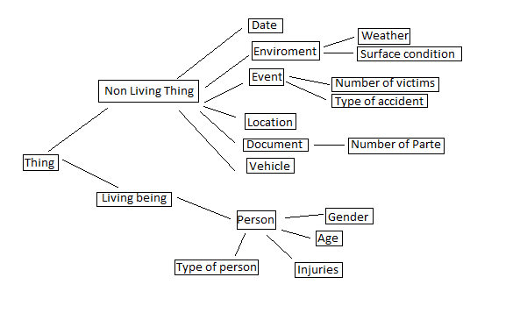

Prefix xsd:

Prefix owl:

Prefix xml:

Prefix rdf:

Prefix dc:

Prefix rdfs:

Prefix ra:

Prefix:

Ontology:

AnnotationProperty: rdfs:comment

Datatype: xsd:positiveInteger

Datatype: xsd:anyURI

Datatype: xsd:date

Datatype: rdf:PlainLiteral

Datatype: xsd:boolean

Datatype: xsd:string

Datatype: xsd:integer

ObjectProperty: ra:isIn

Annotations:

rdfs:comment "anything can be in anything"@en

EquivalentTo:

ra:isOn

Domain:

owl:Thing

Range:

owl:Thing

ObjectProperty: ra:isOn

EquivalentTo:

ra:isIn

Domain:

owl:Thing

Range:

owl:Thing

ObjectProperty: ra:location

Domain:

ra:Event

Range:

ra:Location

ObjectProperty: ra:isPartOf

Domain:

owl:Thing

Range:

owl:Thing

ObjectProperty: ra:involvedIn

Domain:

owl:Thing

Range:

ra:Event

DataProperty: ra:ageRange

Annotations:

rdfs:comment "age at event time"

Range:

xsd:string

DataProperty: ra:gender

Annotations:

rdfs:comment "gender"

Range:

xsd:{men, women, not assign)

DataProperty: ra:vehicleCategory

Domain:

ra:Vehicle

Range:

{"bicycle" , "bus" , "car" , "motocycle" , "truck"}

DataProperty: ra:accidentType

Domain:

ra:event

Range:

{"fall" , "crush"}

DataProperty: ra:weatherCondition

Domain:

ra:enviroment

Range:

{"earthquake" , "flood" , "ice" , "mud" , "normal" , "rain" , "smoke" , "snow" , "wind"}

DataProperty: ra:surfaceCondition

Domain:

ra:enviroment

Range:

{"wet" , "dry" , "oil"}

DataProperty: ra:relatedInjury

Annotations:

rdfs:comment "use some kind of existing classification"

Domain:

ra:LivingBeing

Range:

{"fatal" , "light" , "none" , "severe"}

DataProperty: ra:address

Domain:

ra:Location

Range:

xsd:string

DataProperty: ra:date

Domain:

ra:notLivingthing

Range:

xsd:date

DataProperty: ra:ParteID

Domain:

owl:Thing

Range:

xsd:string

DataProperty: ra:numberOfVictims

Domain:

owl:event

Range:

xsd:integer

Class: owl:Thing

Class: ra:LivingBeing

DisjointWith:

ra:NonLivingThing

Class: ra:Event

SubClassOf:

ra:NonLivingThing

Class: ra:Location

SubClassOf:

ra:NonLivingThing

Class: ra:Document

SubClassOf:

ra:NonLivingThing

Class: ra:Person

SubClassOf:

ra:LivingBeing

Class: ra:Vehicle

SubClassOf:

ra:NonLivingThing

HasKey:

ra:vehicleID

Class: ra:NonLivingThing

Annotations:

rdfs:comment "Top class for non living thing like vehicle, robot, etc"

DisjointWith:

ra:LivingBeing

Reference:

W3C, Road Accident Ontology (2012). Editor: Daniel Dardailler, July 21th 2012, Finalized the runtime ontology using OWL2 [Manchester](http://www.w3.org/2007/OWL/wiki/ManchesterSyntax) syntax. <https://www.w3.org/2012/06/rao.html#graph>